EXPERIMENT – 2
2. Perform basic Image Handling and processing operations on the image is
to read an image in python and Convert an Image to Blur using Gaussian
Blur.
Aim
To read an image using Python and OpenCV and apply Gaussian Blur to the image.
Procedure
1. Import the OpenCV library.
2. Read the input image using cv2.imread().
3. Check whether the image is loaded successfully.
4. Apply Gaussian Blur using cv2.GaussianBlur().
5. Display the original and blurred images.
6. Wait for a key press.
7. Close all image windows.
Program
import cv2
image = cv2.imread("image.jpg")
if image is None:
print("Image not found!")
else:
blurred = cv2.GaussianBlur(image, (15, 15), 0)
cv2.imshow("Original Image", image)
cv2.imshow("Gaussian Blurred Image", blurred)
cv2.waitKey(0)
cv2.destroyAllWindows()
Sample Input
image.jpg
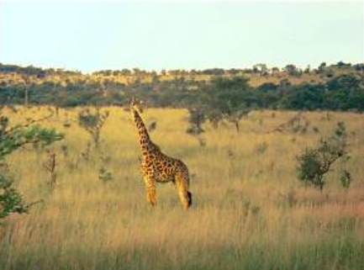
Sample Output
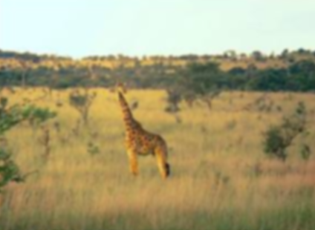
Result
Thus, the image was successfully read and Gaussian Blur was applied using Python and
OpenCV

